The Value of Deception in Resilient Basing

MAJ Olin Kennedy

Lt Elisha Palm

Dr. Mark Gallagher

Lt Col Timothy Holzmann, PhD

Air Force Institute of Technology (AFIT)  
Wright-Patterson Air Force Base, Ohio

**Abstract**  
Adversaries of the United States have prepared to attack the infrastructure of the air power. ….

Our Monte Carlo model confirms the insights of previous research that there is little that can be done if the enemy decides to conduct an overwhelming missile attack. However, interesting insights are available if the missiles are considered scarce and the quantity of missiles used to attack aircraft on an airbase is roughly equal to the enemy’s assessment of the number of aircraft presents. Desired outcomes such as getting the enemy to waste the maximum number of missiles (i.e. missiles that don’t hit targets) and maximizing the amount of aircraft available for retaliation sorties afterwards are able to affected by either inducing the enemy to overestimate the number of aircraft at the airbase, or underestimate the number of aircraft at an airbase, respectively.

Additionally, we find that the cost of decoy aircraft dominates the solution space given that they are an order of magnitude cheaper than hardened shelters or even non-protective sunshade type shelters. Recommendations based upon the findings of this study conclude that the Air Force should heavily consider the procurement of high-quality decoy aircraft and develop a concept of deceptive operations with the decoy aircraft that nests within the agile combat employment construct.

**Key Words:** Base resiliency, deception,

**Disclaimer:** the views presented in this article are those of the authors and do not necessarily represent the views of Department of Defense or any of its components.

# Introduction

The world watched on nightly news as the United States lead coalitions in the Gulf War, 1990-1991, and the Iraq War, 2003-2011. In both wars, the United States spent months moving forces into theater prior to conducting a devastating and rapid bombing and ground campaigns. The Iraqi army with 900,000 soldiers was only exceeded in size only by those of China, the Soviet Union and Vietnam (PYLE, 2003). Since then, the security environment for the United States (US) has dramatically changed in the last 30 years. China and Russia have acquired long-range precision munitions that are designed to damage or destroy fixed facilities and assets (Lynch et al., 2023). Hence, the potential adversaries of the US have invested to prevent a military buildup in future theaters of combat. To address these concerns, The Secretary of the Air Force list seven operational imperatives to reconfigure the United States Air Force (USAF) and Space Force (USSF) (Pope, 2022). The fifth imperative is to improve base resiliency.

In this research, we initially focused on the Resilient Basing (RB) imperative in the Indo-Pacific region, which builds on a concept known as Agile Combat Employment (ACE). ACE converts a fixed airfield strategy into a more flexible posture that provides greater mobility by using clusters of locations, which makes targeting major assets more difficult (Lynch et al., 2023). The resulting questions are what investments and strategies should the Department of Defense (DOD) employ to mix defenses, hardening, deception, and proliferation?

# The Problem

The realization of ACE requires a number of costly investments in mission command, logistics, prepositioned supplies, and the additional training of airmen. There is likely a number of years before the concept can be fully realized to the point of effectiveness. Similarly, existing air defense systems are likely not as capable against newer missile types such as hypersonic glide vehicles and hypersonic cruise missiles. They are also expensive and vulnerable to attack themselves. Acquisition of new air defense systems is expensive and time-consuming. Research, Design, and Acquisition of new air defense Systems able to counter the hypersonic threat is likely even more expensive and further away on the time horizon.

Passive measures, such as intra-airfield aircraft dispersion and infrastructure hardening, are likely the cheapest and easiest to implement (Lynch, et al., 2023). Though there are limits to the effectiveness of passive measures, these solutions have the greatest potential of being implemented at scale in a few years, for a comparatively cheap amount, on a short time scale. The need for quick-to-implement solutions is part of the motivation of this study to focus on the role of deception and passive measures in Resilient Basing. To better understand the problem space, we start out at the top level of the problem.

# Stakeholders, Values, and the Solution Space

Looking at the problem from an Air Force perspective specific to the INDOPACOM theatre, we propose the following stakeholders and values as shown in Table 1.

Table 1

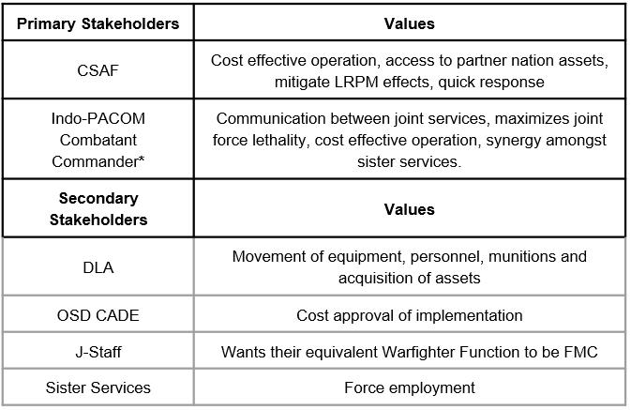

The primary stakeholders from this perspective is the Chief of Staff of the Air Force, who desires solutions that are cost-effective, implementable in a joint/multinational environment, and has the resiliency to respond to aggression. Conversely, the INDOPACOM commander desires force packages that are resilient and flexible enough such that he maintains freedom of action in the event of competition devolving into conflict.

Critical to overall success in a future conflict in the Pacific is the need to sustain aerial operations. Furthermore, these operations need to be achieved in a cost-efficient manner as national resources and defense budgets are not unlimited.

The threat to the status quo is, of course, Chinese Long-Range Precision Munitions (LRPM). The solution space that counters the threat of Chinese LRPM can be characterized by the 3 characteristics: Low-Cost Solutions, Joint/Multi-National Solutions, and “Flexible” Solutions. Low-Cost Solutions are the set of possible solutions that can be attained without significant capital investment. An example of this might standing up a rapid runway repair team to mitigate damage from an attack as opposed with purchasing a new air defense platform.

Joint/Multination Solutions are characterized by the increased cooperation between the Air Force and sister services, as well increased cooperation with host-nation partners. These solutions include using host-nation airbases as alternate locations from the existing fixed forward airbases or using sister service capability to help the Air Force fully realize the distributed ACE concept. Flexible solutions refer to the opposite of static, and is used as a synonym of “Agile” to since Agile is already used to described existing force concepts. An example of a flexible solution might involve containerization of supply such that it can be rapidly transported from one airbase to the next.

I have generally thought the division was between offensive and defensive actions, where defensive may be divided into active defense and passive defensive. Doesn’t ACE employ both active and passive defense?

Generally, I view ACE as not being a type of base defense, but being a survivability tactic that is different from active and passive measures. To use an Army example, say you have an assembly area somewhere. You might camouflage some of your positions (Passive), you’d array your heavy weapons in some logical way with defined fields of fire (Active) and these represent what you can do at a single location. Now, the decision to make a survivability move and change location is a separate type of action from the active and passive measures you can take to defend yourself at a single location.

Your comment did make think about if having 3 solution types adds value or just muddies the water. I try again with the below changes. If the below doesn’t work, we can just go down to two type or not specify the types.

Additionally, there are 3 solution types: Access-Based, Passive Defensive, and Active Defensive. Access-Based solutions are those that involve movement and maneuver of forces, supplies, etc. that promote survivability against LRPM. The locations gained from the access-based solutions enable the Agile Combat Employment (ACE) concept. Passive defense measures are those that are immovable and include the hardening of base infrastructure, runway repair capability, asset dispersion, and deception. Active defensive measures actively defend against the Chinese missile threat by detecting and shooting down the missiles. This is summarized in Figure 1.

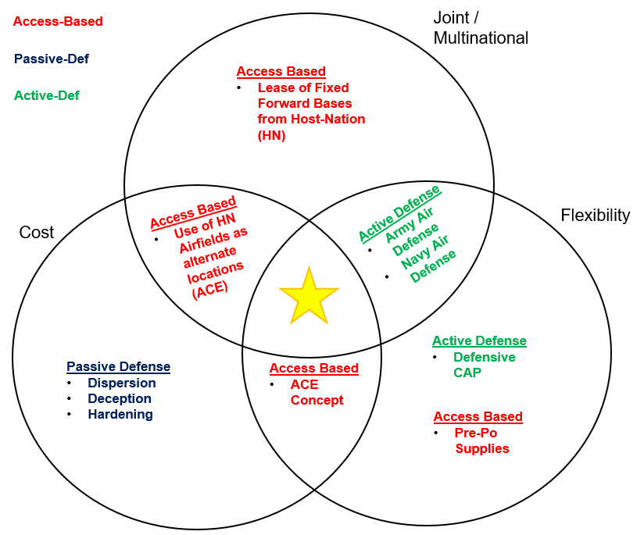

Figure 1

The gold star represents the best theoretically possible solution, but may not exist in practice. There is a long history of inter-service rivalry that makes joint cooperation hard to accomplish as depicted in (Vick, Zeigler, Brackup, & Meyers, 2020). That is why COCOMs were created in 1986. Multinational cooperation can also be considered quite fickle, particularly outside of the countries with deep security ties to the United States already (Orletsky, et al., 2023)

An initial literature review of studies revealed a plethora of existing models that can help decision-makers select wise investments into RB and ACE along the lines of hardened infrastructure and certain capability investments. The value of deception is mentioned as an effective and cost-efficient strategy in a cursory fashion; however, provisions for the use of deception are not included in the papers and models that we examined. This research seeks to fill that gap by providing an initial estimate of the potential cost and effectiveness of a deception strategy.

Research questions that this research answers are:

1. What is the potential value of deception?
2. Given a model that produces the value of deception and cost-estimates of the tolls required to pull it off, Is it cost-effective to acquire the tools of deception?
3. How are outcomes affected if you could induce the enemy to overestimate and underestimate your force posture through deception?

# What is Deception and How to Model it?

# Previous work defines deception in a military context as the practice of deliberately inducing misperception in another for tactical, operational, or strategic advantage (Gerwehr & Glenn, 2000). Gerwehr et al., in their study of deception, highlight the importance of decoys and their ability to feint to deflect enemy attention.

# Why Shell-Game?

Shell Game, as a deceptive measure, would be characterized as a low-cost solution in Figure 1. If a theoretical case can be proven towards its effectiveness, the Shell Game Solution can be upscaled to multiple locations, including joint and multinational installations as a multiple of its relatively cheap cost. It has the potential to be at the intersection of the 3 characteristics of the solution space, the gold star location.

Figure 2

The figure on the right indicates that the “Shell Game at Bases” alone could reduce the cost below “Cost of LPRM to Destroy Bases.” I suspect that the US must do both “Shell Game of Bases” and “Increase Cost of LPRMs to Destroy Bases”, hence the green dash line should be in the theta sector. I would prefer “blue” and “red”. I think the four approaches should have names that do not include “cost”. Such as:

1. Fully-Capable Air Bases
2. LRPM to Destroy Air Bases
3. Additional Austere Air Bases
4. LRPM to Destroy Deceptive Air Bases

I changed the figure based upon your feedback. The right side should now be interpre

As depicted in Figure 2, the promise of shell game is that it is a potential cost-imposing strategy where the friendly cost of playing shell game can only be mitigated by the more expensive action of building and deploying more missiles in an attack to achieve a baseline expected outcome. Playing shell-game or otherwise deceiving the enemy might be cheaper than the enemies cost of constructing more missiles. Cost curves depicted in Figure 2 are aspirational and not-based on real data. Rather, the hypothesis depicted by Figure 2 is the motivation to exploring different models that measure the value of deception.

# The Monte Carlo Model

# We started with a classic shell game as a baseline construct to model deception. Shell game is a street game that con artists still use today to swindle players out of money. An object of interest is placed on a table and obscured by a shell over it. Other shells are placed next to the shell that obscures the object. The player initially knows which shell obscures the object of interest. Then the shells are mixed up in such a way as to confuse the player as to the location of the object of interest. The player's objective is to guess under which shell the object of interest is. However, the con artist typically uses a sleight of hand such that the player guesses incorrectly.

# Let's presume that the shell game is modeled where *p* represents the number of prizes, *s* represents the number of shells in play, and g represents the number of guesses the player can use. Thus, the classic shell game is played with parameters *p* = 1, *s* = 3, and *g* = 1. Using shell-game as a construct, we built two simple models.

# The Monte Carlo model examines the relationship between p, s, and g on a range of outcomes. In a military context, *p* represents an aircraft, *s* represents a structure or shelter that obscures the aircraft from view, and *g* corresponds to an enemy guess at the aircraft location, made by launching a destructive missile there. Simplifications in this model are that structures do not provide any protection against a missile launched at the aircraft underneath, and decoy aircraft do not exist.

I remove the fuel bladders from the model since they don’t add anything interesting

# The probabilistic model built is based upon calculations of the probability of kill of a missile launched at aircraft on a single airbase, but the following embellishments are made: decoy aircraft are present that complicate targeting, structures may or may not provide protection to the aircraft underneath (depending on their cost).

# Scope and Assumptions

# Both models are scoped to only look at a single airbase. We only model fighter aircraft at each airbase, and the decoys and shelter cost estimates are based on fighter aircraft. Aircraft are assumed dispersed such that missiles with either unitary or cluster munitions can only destroy one fighter. Because of the assumed dispersion, we limit the number of shelters to 32. We assume decoy aircraft are indistinguishable from real aircraft from the enemy's perspective.

We specify the following parameters:

*P* corresponds to the number of prizes or real fighter aircraft present on the airbase being modeled. *G* corresponds to the guesses the enemy gets and can be thought of as the number of missiles the enemy launches at the aircraft at the airbase in a single salvo. *S* corresponds to the number of shells in the shell-game. For our application, S equals the number of aircraft shelters, actual fighters, and decoy fighters. Let be the probability of any individual aircraft being destroyed with the assumption that missile launch at a shelter with an actual aircraft is always successful.

for a single missile attack

for *g* randomly assigned missile attacks

for coordinated strikes on *g* different shelters and 1 otherwise

Since is a Bernoulli variable with mean of and variance . The sum of Bernoulli variables follows a Binomial distribution, which as *g* becomes large follows the Normal distribution.

The procedure for instantiating each simulation is as follows:

1. Instantiate *S* number of shelters, a blue random number generator (RNG), and a red (RNG).
2. Using the Blue RNG, place *P* prizes in a shelter.
3. Using the Red RNG, select *G* number of shelters for attack.
4. Model the attack and tally the results.

Using separate RNGs for the prize placement and shelter selection guarantees independence. Then, each scenario is run 1000 times. The number of scenarios being evaluated is based on full enumeration of the combinations of *P, S*, and *G*. The measures being recorded in the experiment are as follows:

1. Surviving Fighters as a percentage of fighters present on the airbase (%) and Average number of surviving fighters.
2. Miss Percentage of the missiles and the average number of missiles missed.

The Monte Carlo model revealed a flat response surface in terms of the miss percentage of enemy missiles. This was not wholly unexpected since the factors that drove the probability of a missile hit or miss was the number of missiles fired in the Monte Carlo versus the number of aircraft hidden underneath the shelters. The number of surviving friendly aircraft showed a similar linear response surface.

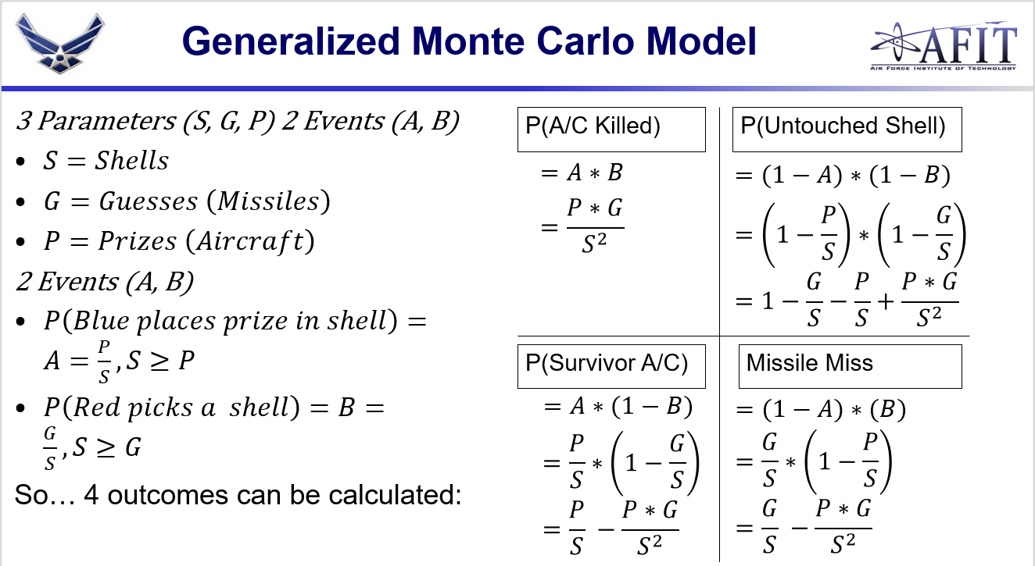

The resulting constant probability of subsequent missiles missing (1-hitting) a target seems to only result if you count hitting an aircraft a second time as a successful strike.

I’m visualizing all of the missiles being fired in a single volley rather than a series of independent missile launches.

Figure 3. Response Surface of Surviving Fighters vs. Starting Aircraft and Missiles Fired. Color use

Figure 4. Response Surface of Missile Misses vs. Number of Missiles Fired and Number of Starting Aircraft

These response surfaces show that any strategy in deception using shells alone can be countered by launching more missiles at the modeled base. In other words, any deception strategy can be brute force defeated by launching an overwhelming number of munitions.

Given any deception strategy can be overwhelmed by an overwhelming missile attack, what happens if the enemy treats their missiles as scarce resources? This is not an outrageous assumption, as a missiles take time to produce. One could assume that the missile attack on the airbase might be the opening act of a conflict, but some level of missiles must be preserved for future use in the conflict. This creates a desire to be judicious in the use of missiles in the attack on the airbase, which leads to a subsequent modeling assumption where the enemy will try to match missiles to aircraft at the base.

In the second iteration of this model, we assume instead that the enemy will launch the same number of missiles at an airbase equal to the number of fighters present at the airbase. This can be thought of as the enemy has some way to accurately estimate the number of fighters present (by perhaps observing some proxy activity) but cannot observe which aircraft are parked under which shells. Number of shells remain constant at 32, but the number of actual aircraft on the airbase is varied and the missiles launched equals exactly the number of aircraft on the airfield such that *g = p* in each scenario.

As actual fighters are added, more may survive; however, as more aircraft are added, then more are likely to be destroyed. What was discovered was that if a Commander wanted to maximize the number of surviving aircraft available for post-attack sorties, then he could do so by using a ratio of 1 aircraft to every 2 shells on the airbase. I wonder if this result could be derived. Good Idea!

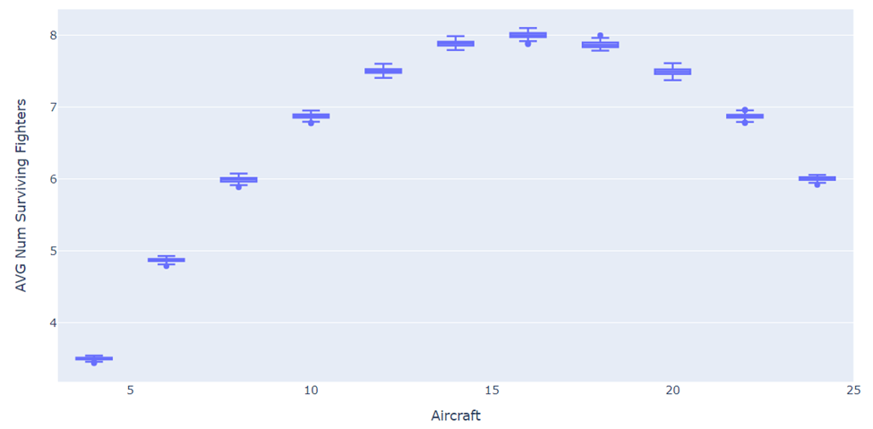

Figure 5

Figure 4 actually generalizes quite nicely into Equation 1:

(1)

Correspondingly, it’s simple to calculate expected missile misses from Equation 1 using Equation 2:

(2)

Figure 6

To create the data for Figure 5, the two introduced equations are used to create a table where the or Aircraft on base is varied. The number of guesses is linked to the number of prizes, signifying different propensities to launch a given number of missiles at a given number of aircraft.

Figure 5 left shows the effect of varying the number of missiles (i.e. guesses) the enemy makes in a missile attack on the expected number of surviving aircraft according to the generalized equation above it. If one wished to maximize the aircraft available post-attack, then there would be value in inducing the enemy to fire fewer missiles. Conversely, Figure 5 right shows that additional missile misses (or missile wastage) are likely to occur if the enemy can be induced to fire more missiles than there are targets available. What both sides of the figure have in common is that diminishing returns are evident as one approaches the ½ ratio of aircraft to shells from the left side. In other words, neither metric appears favorable past 16 aircraft on ground.

There appears to be something interesting worth investigating in inducing error if we presume that the missiles are dear to the enemy and that the enemy can be induced into making either a high-side or low-side error in the number of missiles he uses in an attack to destroy aircraft on the ground. To investigate this, we made further additions to the Monte Carlo model. For the third iteration of this experiment, we embellish the model with a friendly strategy to encourage uncertainty and then model the enemy’s uncertainty of successfully guessing the number of aircraft located at the airfield. Now *P* and *G* are both derived from a probability distribution and we drop their prior full enumeration.

The third iteration runs in the following steps:

1. The friendly side sets the number of aircraft at that base according to a uniform distribution.
2. The enemy side collects intelligence to estimate the number of aircraft and their location on the airfield for targeting. The equation that governs this step is:

Generally, accuracy is modeled as an change in the distribution variance, not a separate term.

1. Then, Monte Carlo simulation is used to generate the outcomes of the experiment, e.g. how many missiles were fired at the aircraft, how many aircraft are destroyed, etc.

The friendly strategy can be typified by the uniform distribution depicted below. This is tantamount to an operating posture that maintains a minimum of eight aircraft at an airbase, but the entire squadron can be dispersed over some area that includes airbases not modeled here.

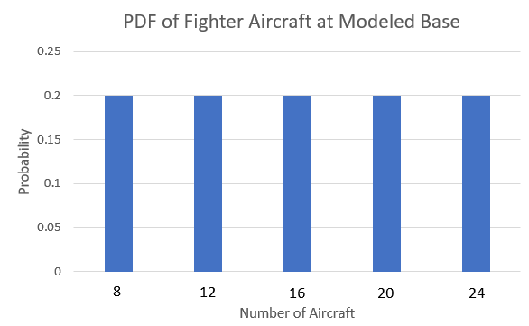

Figure 6

The enemy ability to target those aircraft is modeled in four different ways as depicted in Figures 7-10. In the first scenario (as depicted in Figure 7), we presume a relatively tight distribution of the possible modifiers. The enemy guesses correctly the number of real aircraft at the airbase half of the time, and either under or overestimates the number of aircraft half of the time.

Figure 7

In the second pdf, we assume that a squadron can deploy effective decoy aircraft at the airfield. This has the effect of creating dispersion in red’s estimation of the number of aircraft truly on the airfield.

Figure 8

For the final two pdfs, we assume that it’s possible to operationalize the shell game with decoys in such a way that blue can cause red to either consistently overestimate the number of aircraft (i.e. High-end bias) or consistently underestimate the number of aircraft present at the airbase (Low-end Bias).

Figure 9

Figure 10

So, what was the difference in outcomes produced by the model, based upon the inducement of enemy estimation error typified by the different enemy pdfs? Figure 11 shows that we can induce the enemy to miss with missiles shot, but only at having a relatively low number of aircraft on the airbase. This further suggests that there is potentially value in getting the enemy to underestimate the number of aircraft on the airbase.

Figure 11

Similarly, Figure 12 shows that it’s possible to reduce the number of aircraft destroyed by limiting the number of aircraft at risk at the airbase.

Figure 12

The first two examples both show outcomes in terms of enemy missile efficiency and demonstrate an implicit desire for to reduce said efficiency. But what if a decision-maker would like to maximize the number of surviving aircraft available from the specific modeled base for post-attack response? Once again, you can maximize the number of fighters available post-attack by maintaining a real-aircraft presence of 1 aircraft to every two shelters.

However, this requires both risking more fighters at the main base and inducing the enemy to make low-biased guesses. Given the cost ratio between fighter aircraft and cruise missiles, this COA might not be considered appetizing. This result is highly reliant on the assumption of several missiles based upon the assessment of the number of aircraft at the airbase.

Figure 13

Lastly, could a decision-maker maximize the absolute number of missiles that the enemy might waste? Given a relatively low number of aircraft present at the airbase and a deception strategy that induces a high-biased estimate of aircraft at the airbase, you could induce a higher number of missile misses.

Figure 14

Overall, the third iteration of the Monte Carlo Model used confirms the insights produced by using Equations 1 and 2 to produce hypothetical data.

# Insights from the Monte Carlo Model

1. If the goal is to induce the enemy to waste missiles (i.e. maximize missile misses), then we can adopt a force posture of having relatively few aircraft at a base while operationally inducing the enemy to overestimate the number of aircraft I have at the base
2. If our goal is to maximize the aircraft we have immediately available for a retaliation strike, then we can do this by posturing aircraft forward at the base under study and operationally induce the enemy to underestimate the number of aircraft I have at the base. However, this COA is subject to the enemy also knocking out the runway and other necessary facilities for sortie generation.
3. If the goal is to minimize the number of aircraft destroyed on the ground in a missile attack, then the policy would be to keep as few aircraft at the attacked base as possible, with the majority of the aircraft deployed to some other place under the ACE concept. Of course, this is also contingent on keeping hidden the location of those wayward aircraft in theatre.
4. No amount of strategy can account for the possible enemy action of an overwhelming missile strike. In such a scenario, there isn’t a way to counter with deception or other means the destruction of all the aircraft present.
5. No matter the primary goal of the decision-maker, this model suggests basing fighters at the main airbases at a level less than their presumed capacity. This was modeled at a presumed capacity of 32 fighters in this model. Inducing any of the relatively positive outcomes described here was dependent on stationing 16 fighters or less on the base, or not exceeding 50% of the presumed capacity of the airbase to house fighters.

# Follow on Questions from Monte Carlo Model

The Monte Carlo model suggests a need to induce the enemy to be judicious with his missiles and a need to also throw off the accuracy of his intelligence estimates. Decoys were a suggested way for inducing an error in the intelligence estimates. So the Deterministic model will explore this dynamic by explicating modeling decoys, and also bring in estimated cost data.

# Cost Estimate and Capability Evaluations for the Deterministic Model

In order to understand the monetary impact for decision makers there needs to be proper evaluation of several cost estimates. The key estimates we evaluate are: 1) aircraft protective shelters 2) fighter aircraft and 3) decoys.

The three shelter variations that contribute to aircraft protection are the hardened aircraft shelters (HAS), protective aircraft shelters (PAS), and deployable shelters. The HAS serves as housing for fighter aircraft and can withstand anywhere from 200 to 500+ pounds per square feet (PSI). The next capable shelter, the PAS, offers less protection and can withstand 50-200 PSI. Lastly, the deployable shelter is Kevlar lined which provides moderate protection from bomblet debris and can withstand less than 50 PSI. The volatility of resources, research of past shelter cost estimates and the inclusion of an inflation factor produces cost estimates presented in Table 1.

In this research, we use the F-35 as the sole aircraft under consideration because of it’s assumed utility in the INDOPACOM theatre due to its stealth technology. We weren’t able to find a visual depiction of an F-35 decoy, but were able to find pictures for various other airframes. A visual representation of these decoys can be observed in Figure 15 (*Inflatable Military Aircraft*, n.d.).

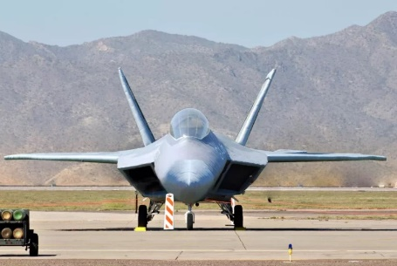 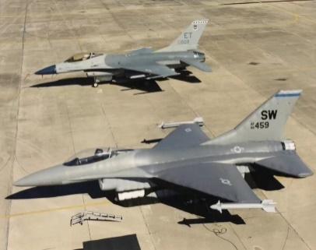 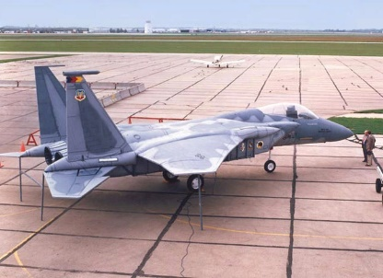

Figure 15: Various Air-Inflatable Decoy Aircraft

The ability of modern-day technology to incorporate different sensory and visual deception techniques further supports the viability of utilizing more affordable options, such as fighter aircraft decoys. The cost estimates for the fighter aircraft and their associated decoys are presented in Table 2.

Table 2

|  |  |
| --- | --- |
| System | Cost FY23$ (millions of dollars) |
| HAS | 7.2 |
| PAS | 3.6 |
| Deployable Shelter | 0.4 |
| Air Inflatable Fighter Decoy | 0.1 |
| F-35 | 78 |

# Building the Deterministic Model

For the Deterministic Model, we assume a fighter squadron of 24 aircraft and that aircraft will be parked under shelters if they are available. If shelters are not available, they will be parked in the open.

Aircraft = 24

Open = Aircraft – HAS – PAS - SUN

The model inputs are defined by the number of shelters or decoys that one could potentially acquire. The Deterministic model will look at full enumeration of the four inputs under the specified ranges.

HAS, PAS, SUN, DECOY ϵ [0: 24]

Where:

HAS = # of Hardened Shelters

PAS = # of Protective Shelters

SUN = # of sunshades (Concealed parking but offers no protection)

DECOY = # of decoy aircraft.

Cost for each set of input variables is estimated with the following equation:

Cost = 7.8*HAS + 3.6*PAS + 0.4*SUN + 0.1*DECOY

Then, we’ll estimate the probability of kill, , with the following equation:

Where:

= overall probability the aircraft is destroyed by a given missile launch

= overall probability that the enemy correctly guesses the aircraft location, governed by the below equation where the denominator is always equal to or greater than the number of aircraft.

The formulation is valid because aircraft are always placed in shelters when available. This is essentially random guessing where # of missiles = # of true aircraft but locations are ambiguously when there are a lot of decoys and/or a lot of shelters.

= The probability that a missile attacking an aircraft under shelter overcomes the protection of the shelter and destroys the aircraft.

is estimated as a weighted average according to the below equation.

Where:

Effectiveness of each set of model inputs is evaluated by the change in that results from the set of model inputs.

Δ = 1 – P_K # valid because we start at the assumption P_K is 1

Cost Effectiveness = Δ / Cost

Because all the parameters are fixed values, we can computationally calculate every combination of the input variables through full enumeration. Over 390,000 solutions were evaluated. Table 3 is the solution set, sorted according to cost effectiveness. The cost-effective solutions are dominated by the decoys, due to their relative cheapness in comparison to the other options.

Table 3

Figure 15 depicts our efficiency measure, Δ, on the y-axis and cost on the x-axis and color depicting the number of decoys in each solution. The pareto frontier is dominated by the solutions that include decoys at any price point.

Figure 18

Of particular interest might be the point of absolute highest effectiveness. Zooming in to Figure, we can see that Δis maximized at a cost of $189.6 million. This solution is composed of having the maximum number of the HAS (24), the most effective and expensive aircraft shelter, and the highest number of decoys (24).

To the right of the most effective possible solution lie more expensive options that appear to be less effective. Those options are less effective because of how P_K is estimated (weighted average). The estimated P_K goes up with the addition of PAS and sunshade shelters, and is not offset enough by the decreasing P_ID of the increasing number of shelters.

$189.6 mil: 24 HAS + 24 Decoys Δ= 0.9

$2.4 mil: 24 Decoys Δ = 0.5

Figure 19

**Insights**

Assuming you can build effective decoys for $100K and operationalize your deception such that they are indistinguishable from real aircraft, then decoys are far and away the best measure one can use to promote survivability of the aircraft on a single airfield, with number of missiles comprising the attack being constant.

**Cost Sensitivity**

To check for sensitivity to price, we changed the cost of acquiring high-quality decoys to $400K, the same price as the sunshades to see if the results would change. The changed cost-effectiveness graph is shown below and shows no meaningful difference from Figure 15 or Figure 16 except that the cost of the most effective solution was increased to $196.8 million from $189.6 million

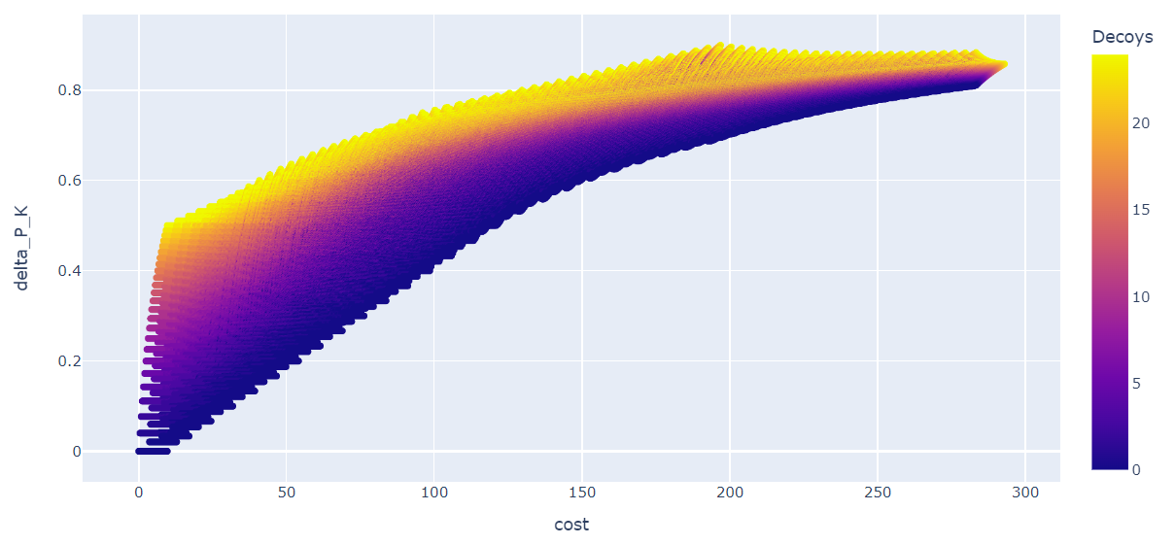

**Recommendations**

Further studies should evaluate how to operationalize deception concepts that are centered around decoys.

Additionally, this study assumes a unit cost of $100K for the appropriate decoys, which was rounded up from the $80K for standard air-inflated decoys that are good visually, but perhaps not suited to fool other types of potential sensors surveying the Pacific (such as synthetic aperture radar). Cost estimates could be done to estimate the development and procurement of an all-sensor fooling ground decoy aircraft.

Other parts of the DoD are looking at operational visual decoys that can fool FLIR systems, and not just visual systems that operate in the visible spectrum. The below example pictures were too cool not to include in this report. (Source: i2K CEO)

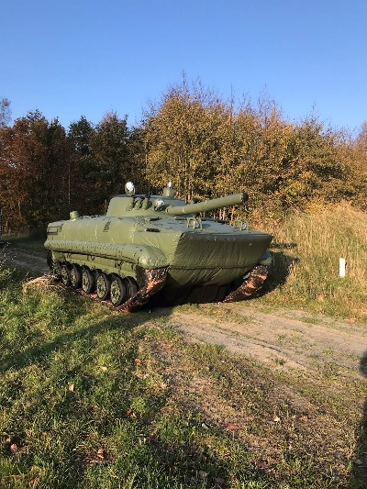 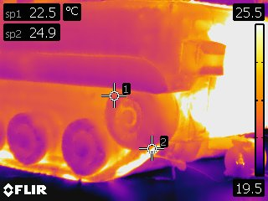

Because a unit cost of $100K for an assumed decoy is relatively inexpensive, we could saturate the pacific theatre with them; they could be deployed to multiple places. Compared to a multi-million dollar cost of an enemy cruise missile (for reference, a tomahawk cruise missile costs $1.5 million), decoys would be cheap.

If the actual cost of convincing decoys remains within the same magnitude of cost, then it’s possible to use them to force adversaries into a cost-imposing strategy where the adversary must accept a lower Δ per missile launched at aircraft or must build and use many more missiles to guarantee a desired result.

# Conclusion

We began this research with four research questions:

1. What is the potential value of deception?
2. How are outcomes affected if you could induce the enemy to overestimate and underestimate your force posture through deception?
3. Given a model that produces the value of deception and cost-estimates of the tolls required to pull it off: Is it cost-effective to acquire the tools of deception?

Deception can be valued primarily in numerous ways: in the outcomes it might produce as the Monte Carlo model shows, or as a change in probability as the deterministic model shows. These first two ways can be then be related to cost-value. In this study, we only related the value to cost in our second deterministic model.

Lastly, we were able to show different post-attack outcomes by varying an enemy’s ability to accurately estimate the number of aircraft at a given airbase.

We also found that decoys are exceptionally cost-effective, at the provided cost and assuming near-perfect performance in fooling the enemy. The low-cost of the decoys dominated the types of shelters that could be built compared to their cost. High quality decoys eliminate any possible value in playing shell game by constructing sun-shade type shelters.

# References

Arabia, C., Bowen, A., Welt, C., & Feickert, A. (2022). *National Advanced Surface-to-Air Missile System.* Washington D.C.: Congressional Research Service.

Cozad, M., Engstrom, J., Harold, S. W., Heath, T. R., Lilly, S., Burke, E. J., . . . Grossman, D. (20223). *Gaining Victory In Systems Warfare.* Santa Monica: Rand Corporation.

Curtis E. LeMay Center. (2022, August 23). Air Force Doctrine Note 1-21.

Gerwehr, S., & Glenn, R. W. (2000). *The Art of Darkness: Deception and Urban Operations.* Santa Monica, CA: RAND Corporation.

I2k Defense. (n.d.). *Inflatable Military Aircraft*. Retrieved from i2kdefense.com: https://i2kdefense.com/inflatable-military-aircraft/

Lockheed Martin. (n.d.). *THAAD Proven Integrated Air and Missile Defense*. Retrieved from lockheedmartin.com: https://www.lockheedmartin.com/en-us/products/thaad.html#:~:text=The%20Terminal%20High%20Altitude%20Area,outside%20and%20inside%20the%20atmosphere.

Lynch, C., Costello, R., Heim, J. L., Karode, A., Mills, P., Tripp, R. S., & Vick, A. J. (2023). *Operational Imperative: Investing Wisely to Bolster U.S. Air Bases against Chinese and Russian Attacks.* Santa Monica: Rand Corporation.

Orletsky, D. T., Brown, J. S., Deblois, B., Mills, P., Norton, D. M., Brackup, J., . . . Guffey, R. (2023). *How Can the Mobility Air Forces Better Support Adaptive Basing?* Santa Monica: RAND Project Air Force.

Pope, C. (2022, 3 3). Kendall details ‘Seven Operational Imperatives’ & how they forge the Future Force. *Secretary of the Air Force Public Affairs*.

Thomas, B., Amouzega, M. A., Costello, R., Guffey, R. A., Karode, A., Lynch, C., . . . Romano, D. N. (2015). *Project AIR FORCE Modeling Capabilities for Support of Combat Operations in Denied Environments.* Santa Monica: Rand Corporation.

Vick, A. J., Zeigler, S. M., Brackup, J., & Meyers, J. S. (2020). *Air Base Defense: Rethinking Army and Air Force Roles and Functions.* Santa Monica: RAND Corporation.

Wong, J. P., Mazarr, M. J., Beauchamp-mustafaga, N., Bohnert, M., Boston, S., Curriden, C., . . . Welch, J. (2022). *New Directions for Projecting Land Power in the Indo-Pacific.* Santa Monica: Rand Corporation.